Name of Student
Instructor’s Name
Date
Motorbike Description
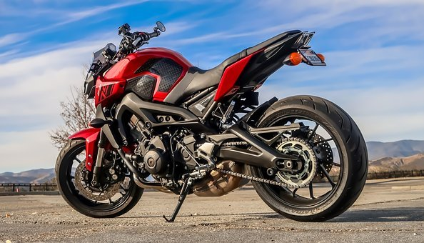
Fig 1.0 source: https://cdn.pixabay.com/photo/2018/02/12/02/05/motorcycle-3147278__340.jpg
Audience and Purpose
The information about the motorbike will be useful and instrumental in the implementation of the details. Besides being a description, it will act as a product review, which is useful in making a choice on whether to buy the item or hire in case of need of its services. The description will also be informative to the reader if they want to know the factors to consider when making the purchase of a motorbike for their private use.
Definition and Function
The motorbike in Fig 1.0 is used mostly in the delivery of items to the neighborhoods. The motorbike is also used in which hiking activities. Bike riding with friends becomes an essential element in people's health since there is the breathing of fresh air on the plains, valleys, and mountains. We have organized bike riding activities with friends during the weekends, holidays, and festive seasons on several occasions. Instead of feasting, we prefer bike riding sessions. The other purpose that the bike is used is the early morning workouts, where I ride for a distance of five kilometers before the day's activities. Therefore, it is one of the types of equipment that I apply for bodybuilding and keeping physical fitness.
Additionally, the bike is also hied by some friends for team building programs in their workplace. In reality, the maintenance cost is catered by the revenue I get from the hiring services. Every weekend, the bike is either hired, or I use it personally for my activities. At other times during the awareness of health and the need to do work out and observe body fitness, I am involved where we spend time in the awareness campaigns, and we get dues for community activities. I also prefer it as a means of transport when going alone on official or non-official duties since it is more convenient and flexible in the means of transport is dependable. Actually, on Thursdays and Fridays, I prefer using the bike since I do not need casual wear in the workplace. Therefore, the bike is for entertainment purposes and for other social activities where I get a source of income from it.
Overview
Components and Explanations
There are various components of the bike that are basic for anyone to be familiar with before understanding the complex ones.
Engine
The engine is the part of the bike that keeps it in operation. The part is responsible for controlling and regulating transmission and the other processes related to the efficient running of the machine. The engine also has a vital part called the valve that is useful in combustion for circulation of the air in the passage and fueling other parts of the motorbike that require fuel. If a motorbike has no engine, it is rendered nonoperational hence not useful in any riding activities. Figure 1.1 shows an image of an engine
Carburetor
The device is only applicable in a petrol engine where the ignition of spark happens. The carburetor is also a part of the engine, and it contains the valve, tubes, and chambers, which can blend air and fueling to aid in combustion in the engine. Fig 1.2 shows a carburetor.
Cylinder
The engine contains two cylinders that function as livers to the motorbike. A motorbike can contain several cylinders to a maximum number of six in total, which also supports the engine's combustion.
Pistons
These are contained in the cylinders, and they help in the transfer of energy from the engine to the other sections of the motorbike through the movement of ups and downs. Through the same process, the wheels also move.
Fuel tank
The fuel tank is above the engine to store carry and store a sufficient amount of fuel for the bike. It is located in a place where it is easy to read the quantity and fuel consumption.
Oil and fuel filters
Due to the motorbike's operations, dust particles may get mixed with the oil. Therefore, the filters are there in the bike to separate the oil from the particles.
Wheels
The wheels in any motorbike are two rear and front, which have tires, hub, rim, and spokes, which are useful in preventing sliding while the bike is in motion.

Visuals
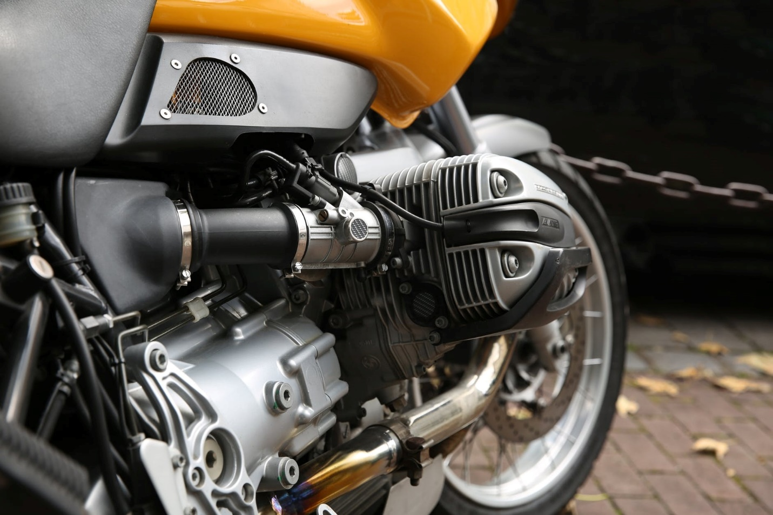
Fig 1.1 source: http://www.motorbikesindia.com/wp-content/uploads/2018/07/MI2-10.jpg
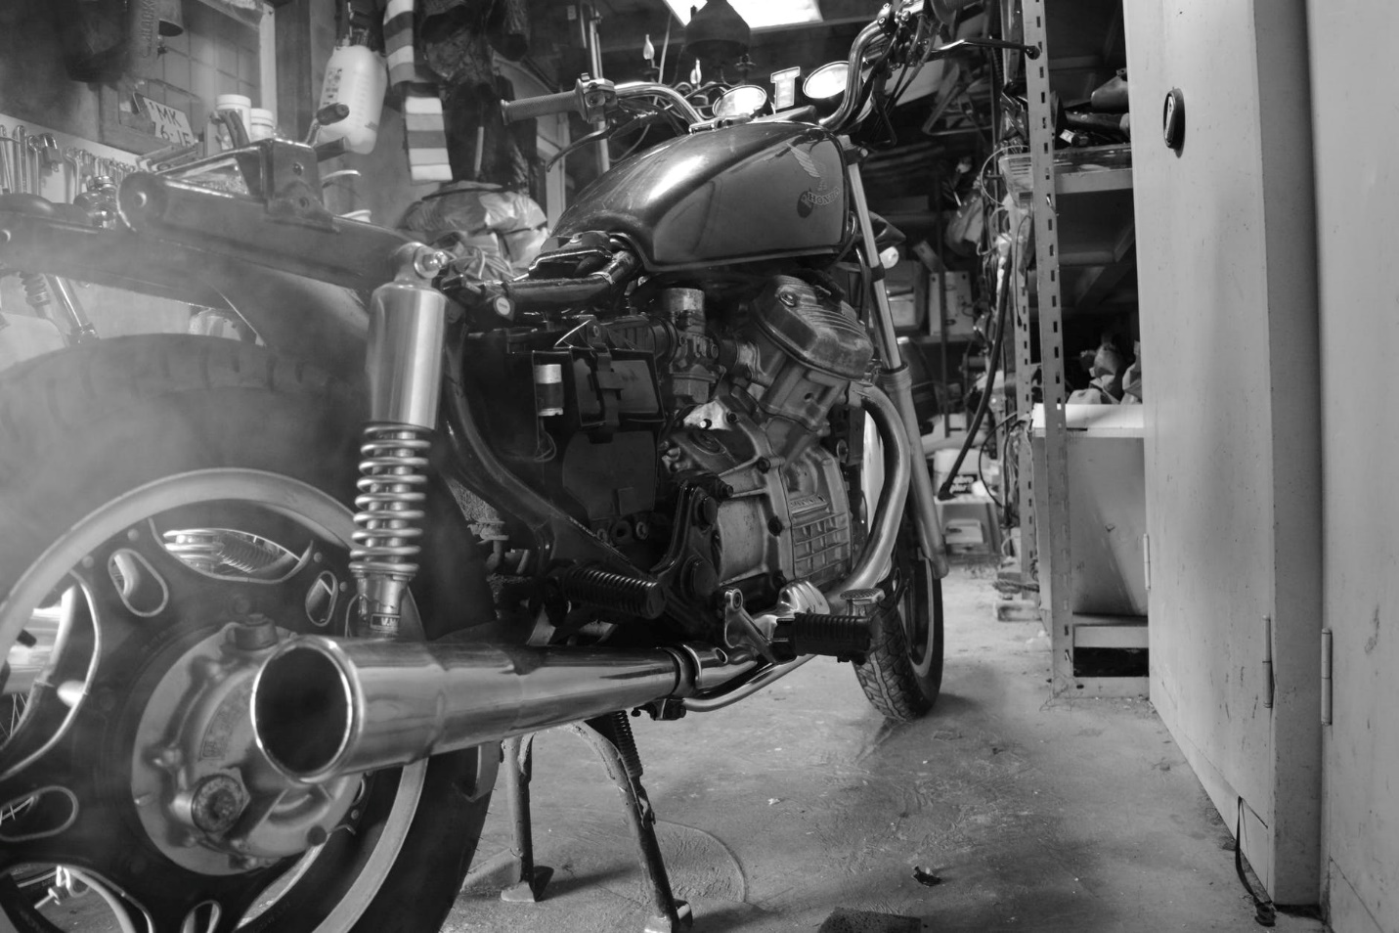
Figure 1.2 source: http://www.motorbikesindia.com/wp-content/uploads/2018/07/MI3-9.jpg
Conclusion
In conclusion, therefore, if anyone is interested in buying a motorbike, they should consider various factors. It is not necessary to purchase a new motorbike if the budget does not allow. However, in buying the used motorbike, consider checking the frame carefully since it is one of the significant motorbike components. The frame of the motorbike should be strong enough to support the entire motorbike. Similarly, the frame is responsible for the steering of the bike. When checking the frame's strength, the key factor is to know the durability of the material used in making the frame.

